Five little men in a flying saucer

Five little men in a flying saucer
Flew round the earth one day
They looked left and right
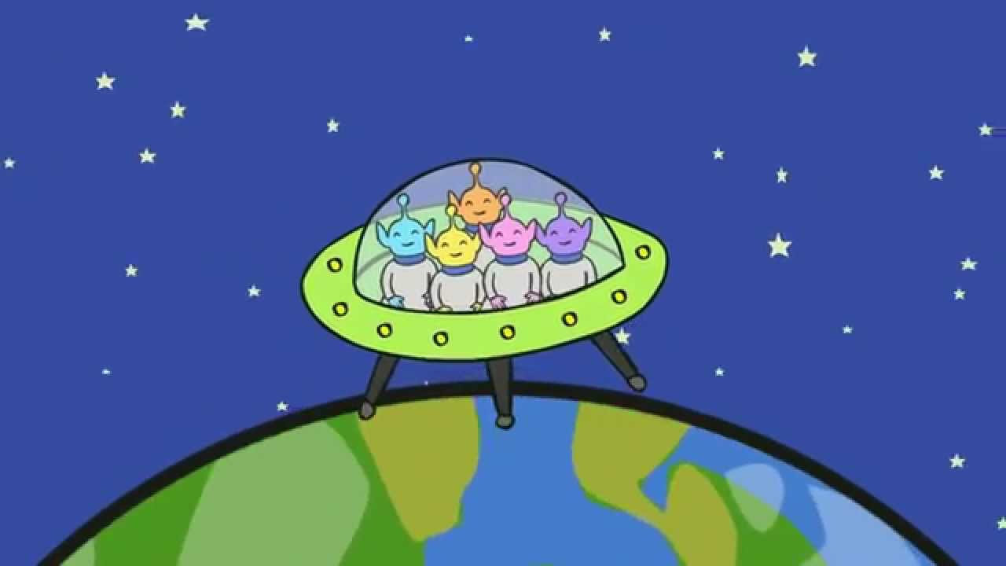
But they didn’t like the sight
So one man flew away.

Repeat 4, 3, 2, 1 …

