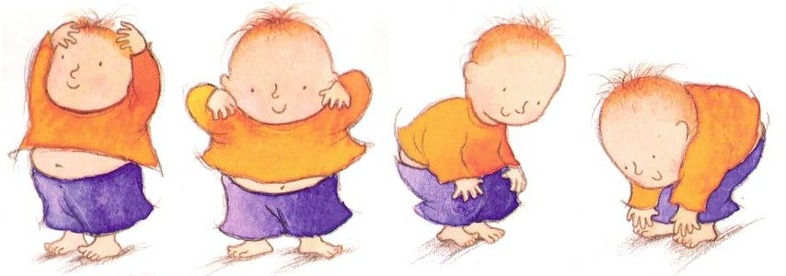
Rhyme of the week
Head, Shoulders, Knees and Toes
Head, shoulders, knees and toes, knees and toes.
Head, shoulders, knees and toes, knees and toes.
And eyes and ears and mouth and nose
Head, shoulders knees and toes, knees and toes.

