Rhyme of the week - Chick, chick chicken
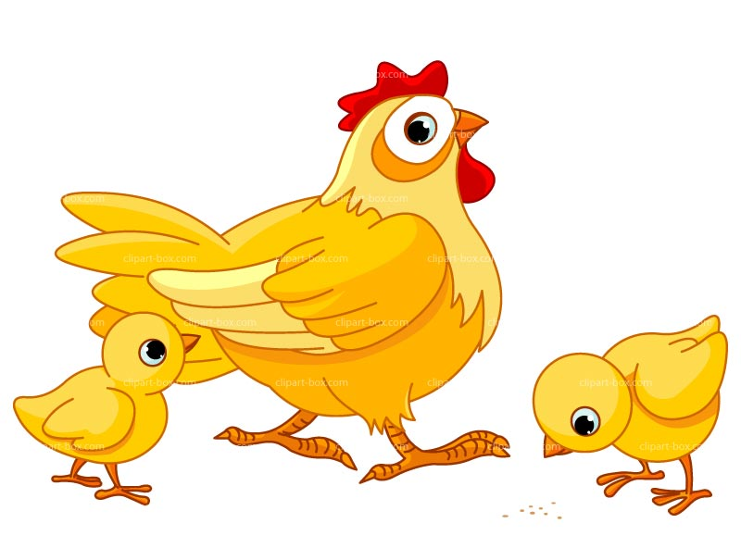
Chick, chick, chick, chick chicken,
Lay a little egg for me.
Chick, chick, chick, chick chicken
I want one for my tea.
I haven’t had an egg since Easter and now it’s half past three
So chick, chick, chick, chick chicken, Lay a little egg for me.

