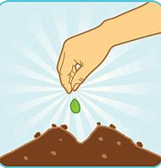
5 Little Seeds

5 little seeds planted in the ground
5 little seeds planted in the ground
Then one little seed grew nice and fat and round
And up popped a flower it didn’t make a sound sshhh.

